**EXPERIMENT 13: CREATE A VIRTUAL HARD DISK AND ALLOCATE THE STORAGE USING VM WARE WORKSTATION.**

**AIM:**

To create a virtual hard disk and allocate the storage using vm ware workstation

**PROCEDURE:**

**STEP 1:**GOTO VM WARE WORKSTATION.

**STEP2:** RIGHT CLICK THE VM AND GOTO THE SETTINGS.

**STEP 3:** ADD HARDWARE WIZARD AND SELECT SCSI AND CLICK NEXT.

**STEP 4:** CREATE NEW VIRTUAL DISK.

**STEP 5:** SELCT THE DISK SIZE AS 2.0. AND SELCT SPLIT VIRTUAL DISK INTO MULTIFILES.

**STEP 6:** GIVE NAME AND CLICK THE FINISH.

**IMPLEMENTATION:**

**STEP 1:GOTO VM WARE WORKSTATION**

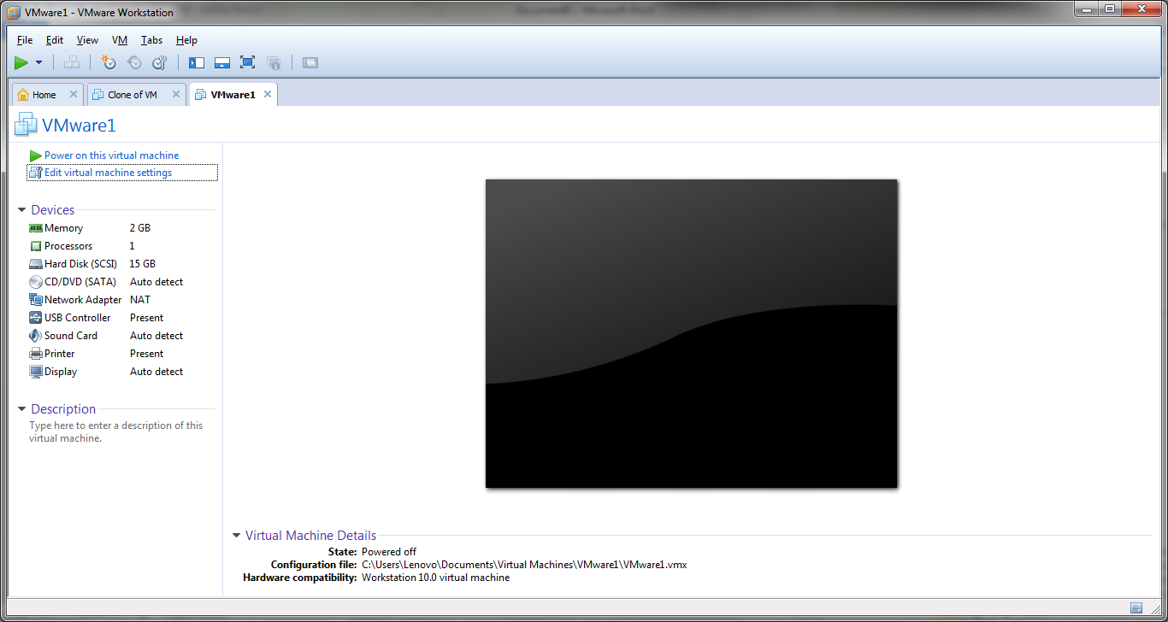

**STEP2: RIGHT CLICK THE VM AND GOTO THE SETTINGS**